29.43:a) The angle between the normal to the coil and the direction of 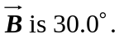
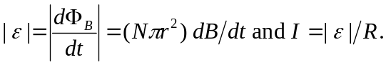
For
For
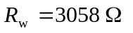and the total resistance of the circuit is 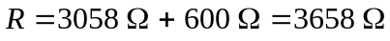
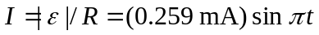
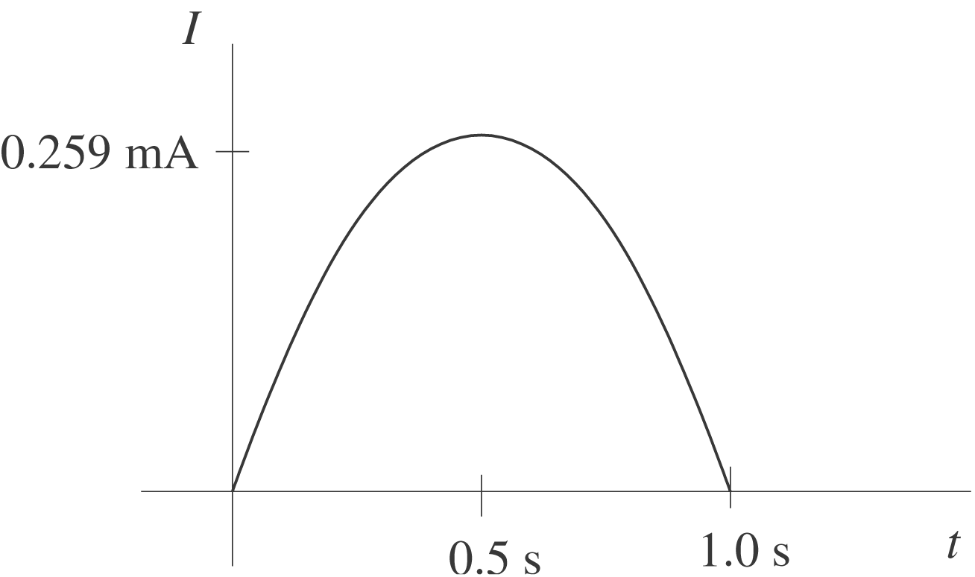

b)
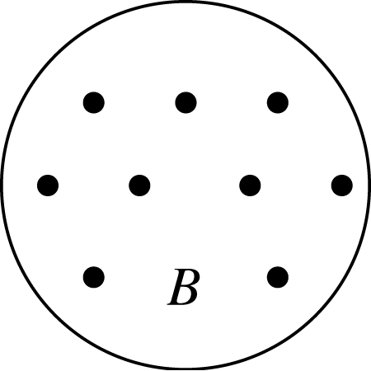 B increasing so 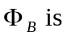⊙ and increasing
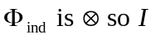 is clockwise

